**The Magnetic Field of a Coil or Solenoid**

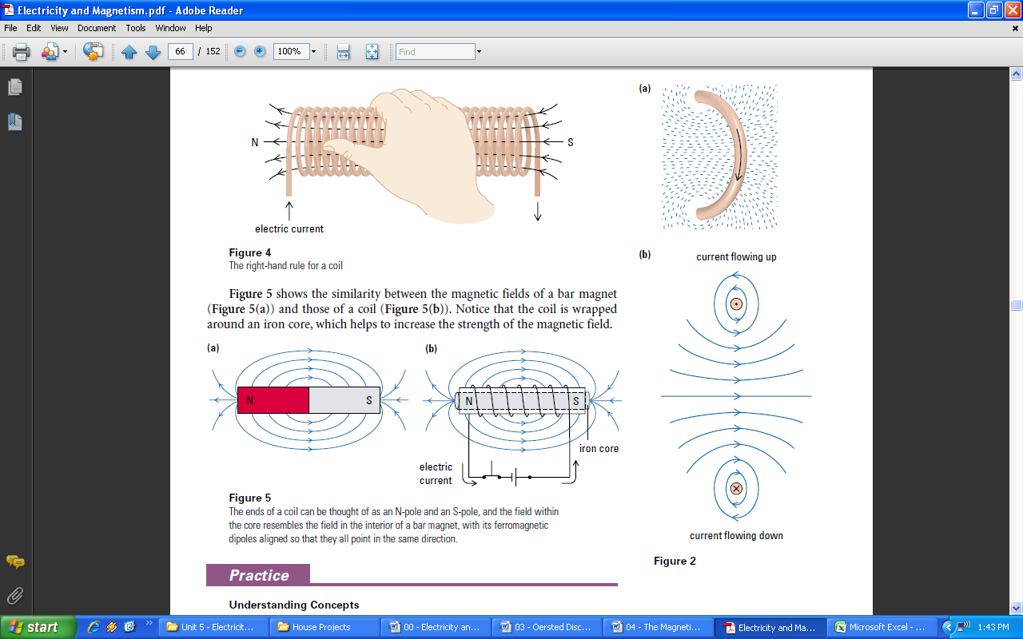

An **electromagnet** is a device that exerts a magnetic force using electricity.

The magnetic field around a straight conductor can be intensified by bending the wire into a loop, as illustrated in **Figure 2**. The loop can be thought of as a series of segments, each an arc of a circle, and each with its own magnetic field (**Figure 2(a)**). The field inside the loop is the sum of the fields of all the segments. Notice that the field lines are no longer circles but have become more like lopsided ovals (**Figure 2(b)**).

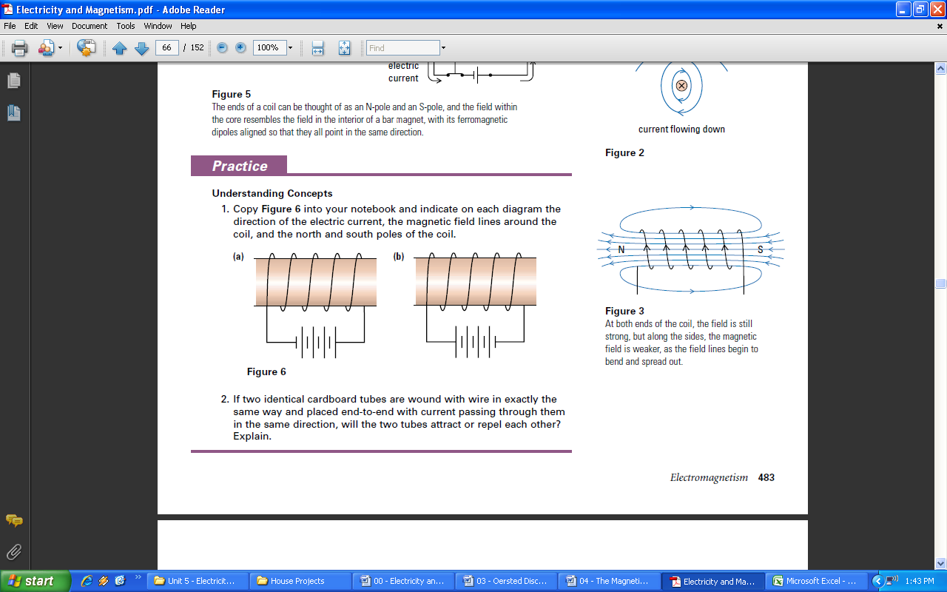

The magnetic field can be further intensified (**Figure 3**) by combining the effects of a large number of loops wound close together to form a coil, or **solenoid**. The field lines inside the coil are straight, almost equally spaced, and all point in the same direction. We call this a **uniform magnetic field**; the magnetic field is of the same strength and is acting in the same direction at all points.

If the direction of electric current through the coil is reversed, the direction of the field lines is also reversed but the magnetic field pattern, as indicated by a pattern of iron filings, looks the same as it did before. To help you remember the relationship between the direction of electric current through a coil and the direction of the coil’s magnetic field, there is the **right-hand rule for a coil** (**Figure 4**).

**Right-Hand Rule for a Coil**

If a coil is grasped in the right hand with the curled fingers representing the direction of electric current, the thumb points in the direction of the magnetic field inside the coil.

**Figure 5** shows the similarity between the magnetic fields of a bar magnet (**Figure 5(a)**) and those of a coil (**Figure 5(b)**). Notice that the coil is wrapped around an iron core, which helps to increase the strength of the magnetic field.

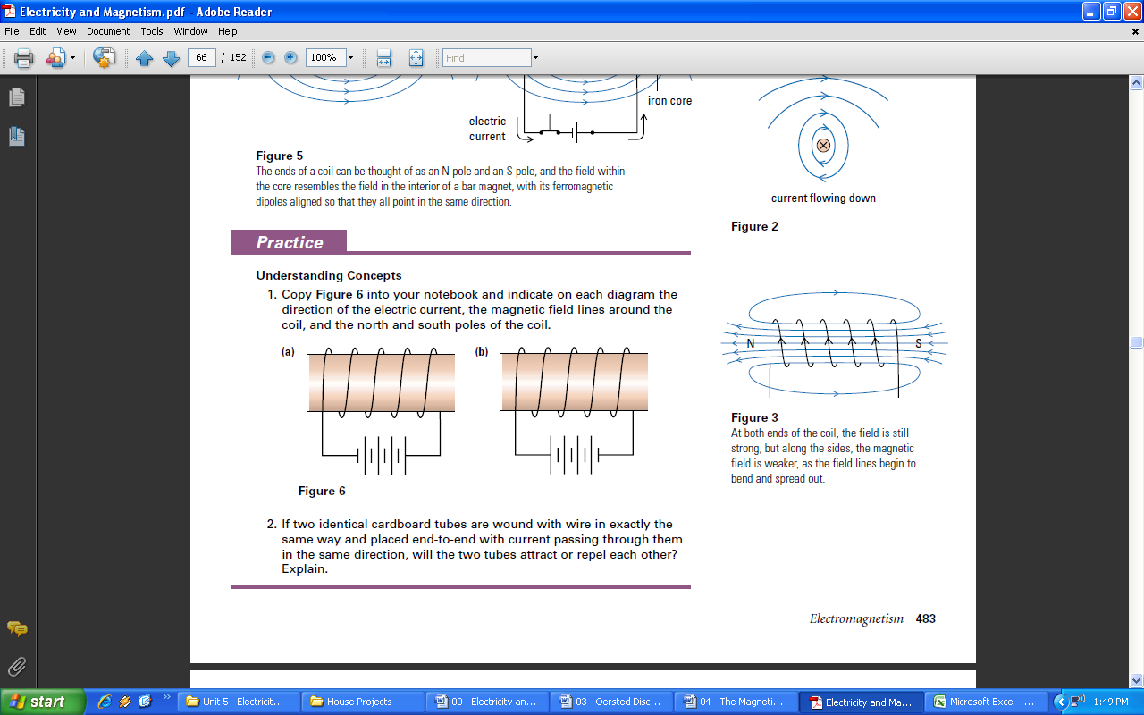

**Factors Affecting the Magnetic Field of a Coil**

The strength of a magnetic field is related to the degree of concentration of its magnetic field lines. To increase the strength of the magnetic field in a coil, you must increase the number of magnetic field lines or bring them closer together. The magnetic field strength in a coil depends on the following factors.

**Current in the Coil**

Since the electric current flowing through the coil creates the magnetic field in the core of the coil, the more electric current there is, the greater the concentration of magnetic field lines in the core. In fact, in an air core coil (a coil with no material inside it), the magnetic field strength varies directly with the current in a coil: doubling the current doubles the magnetic field strength.

**Number of Loops in the Coil**

Each loop of wire produces its own magnetic field, and since the magnetic field of a coil is the sum of the magnetic fields of all its loops, the more loops that are wound in the coil, the stronger its magnetic field. Magnetic field strength varies directly as the number of loops per unit length in a coil: doubling the number of loops in a coil doubles the magnetic field strength.

**Type of Core Material**

The material that makes up the core of a coil can greatly affect the coil’s magnetic field strength. For example, if a cylinder of iron—rather than air—is used as the core for a coil, the coil’s magnetic field strength can be several thousand times stronger than with air. An aluminum core will have almost no effect on the strength.

The core material becomes an induced magnet, as its atomic dipoles align with the magnetic field of the coil. As a result, the core itself becomes an induced magnet and the magnetic field strength increases.

**Applications of Electromagnetism**

Many appliances, tools, vehicles, and machines use a current-carrying coil to create a magnetic field. In most cases, the magnetic field is used to cause another component to move by magnetic attraction. A few examples will illustrate how electromagnets are used.

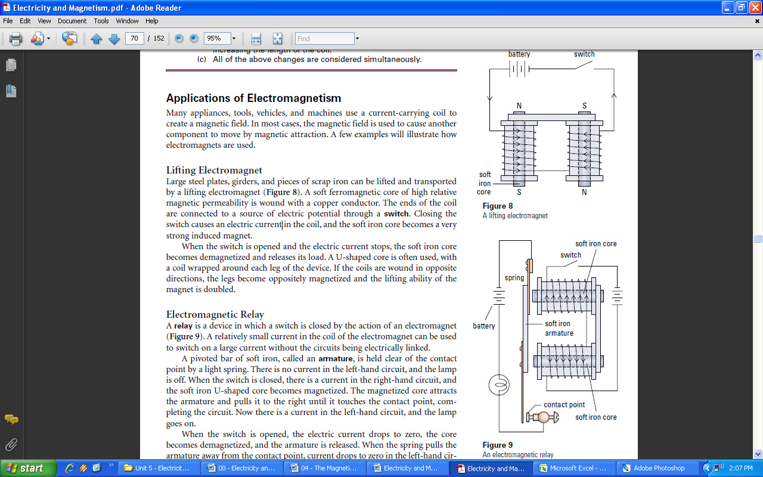**Lifting Electromagnet**

Large steel plates, girders, and pieces of scrap iron can be lifted and transported by a lifting electromagnet (**Figure 8**). A soft ferromagnetic core of high relative magnetic permeability is wound with a copper conductor. The ends of the coil are connected to a source of electric potential through a **switch**. Closing the switch causes an electric current in the coil, and the soft iron core becomes a very strong induced magnet.

When the switch is opened and the electric current stops, the soft iron core becomes demagnetized and releases its load. A U-shaped core is often used, with a coil wrapped around each leg of the device. If the coils are wound in opposite directions, the legs become oppositely magnetized and the lifting ability of the magnet is doubled.

**Electromagnetic Relay**

A **relay** is a device in which a switch is closed by the action of an electromagnet (**Figure 9**). A relatively small current in the coil of the electromagnet can be used to switch on a large current without the circuits being electrically linked.

A pivoted bar of soft iron, called an **armature**, is held clear of the contact point by a light spring. There is no current in the left-hand circuit, and the lamp is off. When the switch is closed, there is a current in the right-hand circuit, and the soft iron U-shaped core becomes magnetized. The magnetized core attracts the armature and pulls it to the right until it touches the contact point, completing the circuit. Now there is a current in the left-hand circuit, and the lamp goes on.

When the switch is opened, the electric current drops to zero, the core becomes demagnetized, and the armature is released.When the spring pulls the armature away from the contact point, current drops to zero in the left-hand circuit and the lamp goes off.

If the contact points were on the opposite side of the armature from the electromagnet, the relay would operate in reverse. Closing the switch would then turn the left-hand circuit off, and vice versa.

**Electric Bell**

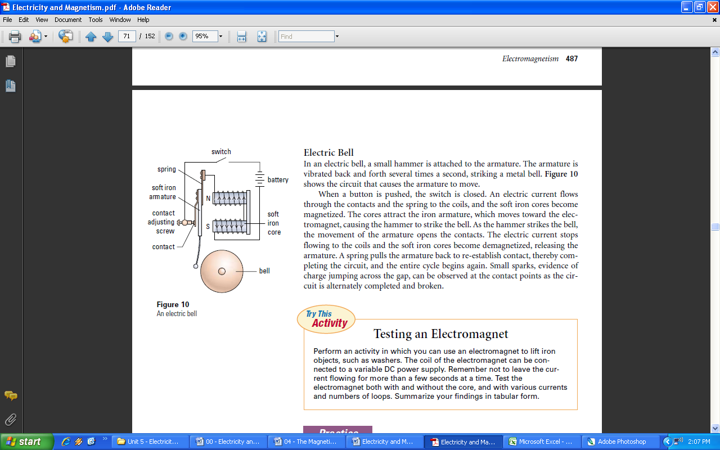

In an electric bell, a small hammer is attached to the armature. The armature is vibrated back and forth several times a second, striking a metal bell. **Figure 10** shows the circuit that causes the armature to move.

When a button is pushed, the switch is closed. An electric current flows through the contacts and the spring to the coils, and the soft iron cores become magnetized. The cores attract the iron armature, which moves toward the electromagnet, causing the hammer to strike the bell. As the hammer strikes the bell, the movement of the armature opens the contacts. The electric current stops flowing to the coils and the soft iron cores become demagnetized, releasing the armature. A spring pulls the armature back to re-establish contact, thereby completing the circuit, and the entire cycle begins again. Small sparks, evidence of charge jumping across the gap, can be observed at the contact points as the circuit is alternately completed and broken.

